# CS 255 System Design Document

## UML Diagrams

### UML Use Case Diagram

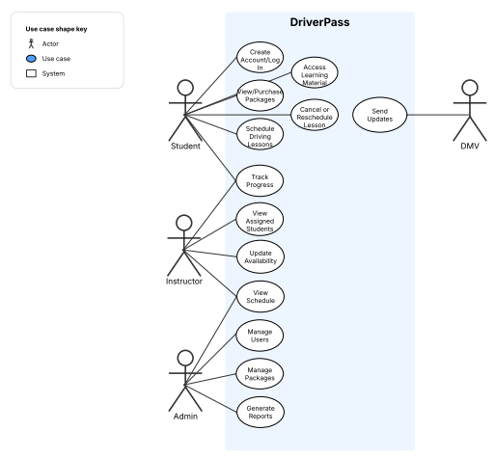

### UML Activity Diagrams

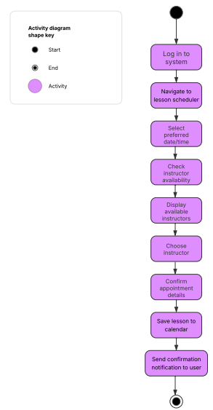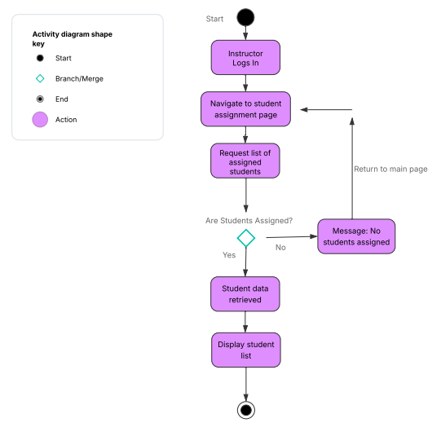

### UML Sequence Diagram

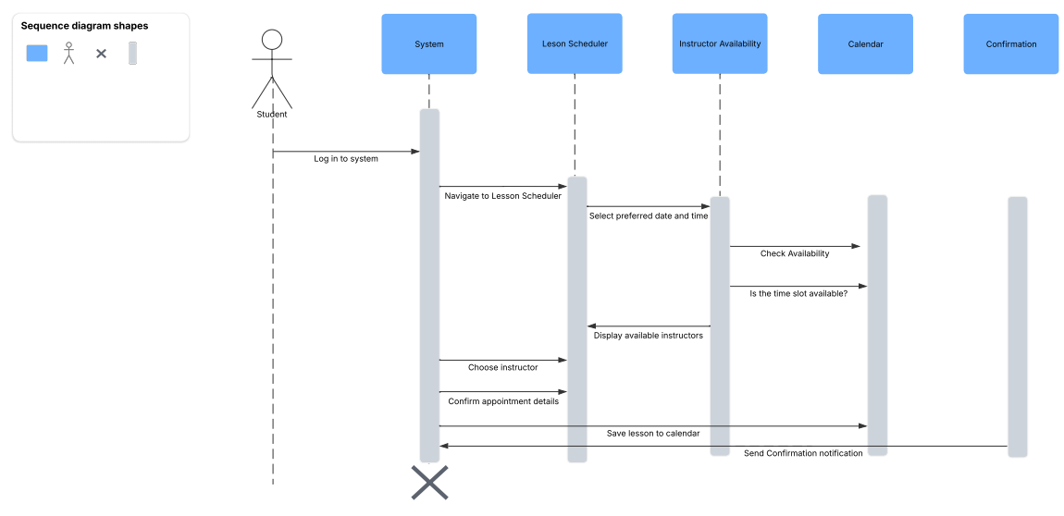

### UML Class Diagram

## Technical Requirements

The technical requirements for the DriverPass system include reliable cloud-based servers to host the backend, database, and user interface. Users will need internet-enabled devices with a modern web browser to access the system. The frontend will require a framework that supports responsive design, while the backend will need a server-side language capable of handling APIs and user interactions. A relational database will be necessary to store user information, progress tracking, and appointment scheduling data. Development tools for version control, system design, and testing will be needed to support the creation and maintenance of the application. Security measures, including data encryption and controlled user access, will be required to protect sensitive information. The hosting environment must also support regular backups, system monitoring, and disaster recovery processes to ensure consistent performance and availability.